(电子手轮)MPG概述
The handheld pulse generator used on CNC machine tools (Manual Pulse Generator)，There are many call：
MPG handwheel, MPG, electronic hand wheel, hand-held unit, handheld pulse generator.
The company specializes in the production of wireless / wired handheld pulse generator (electronic handwheel), fit the world any of a CNC control system, such as Siemens (SIEMENS), Mitsubishi (MITSUBISHI), Fanuc (Fanuc), Fagor(Fagor), Po-yuan, a new generation of JDpaint, NcStudio, GSK, KND, Nordson Adtech ......
The products are widely used in CNC milling machines, machining centers, large gantry milling machine, CNC robotic application machine.
Wireless transmission technology, easy to operate, eliminating the need for the traditional spring wire connections to reduce accidents caused by cable failure rate and the connector is loose. Eliminates cable drag, avoid oil, cable cracking caused by machine failure.
Wireless electronic handwheel (the handheld pulse generator), the receiver via with 18 core spring wire and machine connection, electronic handwheel (the handheld pulse generator) connected communication through wireless transmission technology and the receiver, can support 11 shaft complex mechanical arm, which is unique in the world. The operator can be armed with hand wheel, get rid of the shackles of spring wire connection, you can move around freely, easy to operate, free, stable and reliable, reduce the failure rate (because of the traditional wired hand wheel, you need to connect a spring line, a long time, spring wire the cable is easy to cut off, causing operation failure). Applications for large gantry milling machine, large CNC machine tools, machine tools, such as walking, is a great convenience, improve work efficiency.

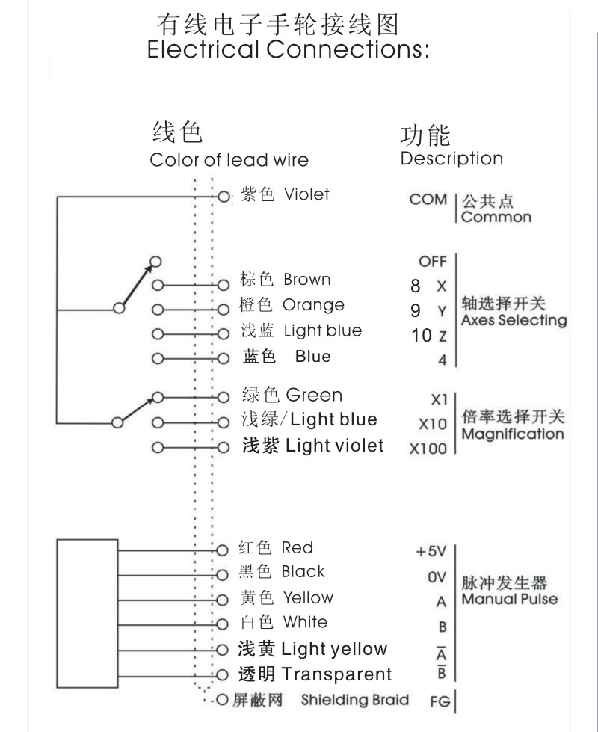

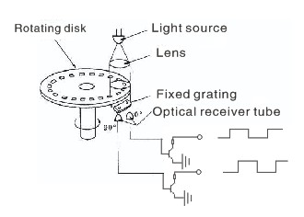

Product Type | GPSeries | Pulse output | 100PPR
Supply range | DC 5v | Current (no load) | ≤60mA
Output Type | Voltage | Voltage Output | Hirht≥ VccX0.7v | Low≤0.5v
Current output | ≤ 35mA | Fall/Puse Time | 5us(Typ)
Frequency Response | 0~5Khz | Isolation resistance | ≥20MΩ
Power LED |  | Product size | 155(with hanging handle)*70*30mm
Product Weight | 525g | Operating / Storage temperature | -10~+60 ℃-20~+70℃
Magnification selection | X1,X10,,X100 | Axial select | OFF,X,Y,Z,4,
Emergency stop switch | Optional | Mounting bracket | Optional
Spring wire specifications | Matt black, 16-core, natural length of about two meters, stretching a length of about 5 meters

